Advanced BMI Calculator
Stephan_Task2
Project Overview
This BMI Calculator is a Python-based desktop application developed as part of the Oasis Infobyte Python Programming Internship. The project helps users calculate their Body Mass Index (BMI), classify health status, store records in a PostgreSQL database, and analyze BMI trends through graphical visualization.
This project demonstrates the practical application of Python programming, database management, graphical user interface development, data visualization, and problem-solving techniques.
Objectives
- Calculate BMI using standard BMI formula.
- Categorize BMI according to health standards.
- Store user records securely in PostgreSQL.
- Display historical BMI records.
- Visualize BMI trends using graphs.
- Provide a user-friendly graphical interface.
Features:-
BMI Calculation-Users can enter their weight and height to calculate their BMI instantly.’
Health Classification- The application automatically categorizes BMI values into:
- Underweight
- Normal Weight
- Overweight
- Obese
PostgreSQL Database Integration-All user records are stored in a PostgreSQL database for future reference and analysis.
Historical Record Viewing-Users can view previously saved BMI records through an integrated history table.
BMI Trend Analysis-The application generates graphical BMI trend reports using Matplotlib.
User-Friendly Interface-The GUI is designed using Tkinter to provide an intuitive and responsive user experience.
Input Validation-The application validates user inputs and prevents invalid values from being processed.
Error Handling-Proper exception handling is implemented to improve reliability and prevent application crashes.
Database Structure:-
Table name is (bmi_records)
Column | Data Type
Id | SERIAL PRIMARY KEY
Name | VARCHAR(100)
Weight | REAL
Height | REAL
Bmi | REAL
Category | VARCHAR(50)
record_date | TIMESTAMP
BMI Formula:-
BMI is calculated using:
BMI = Weight (kg) / Height² (m²)
BMI Categories:-
BMI Range | Category
Less than 18.5 | Underweight
18.5 - 24.9 | Normal Weight
25.0 - 29.9 | Overweight
30 and above | Obese
Creative Elements
- Developed an interactive GUI using Tkinter.
- Implemented PostgreSQL database storage for persistent record management.
- Added historical record tracking.
- Created BMI trend visualization using graphs.
- Improved usability through organized layout and user-friendly controls.
Problem-Solving Approach
- Implemented input validation to prevent incorrect data entry.
- Used exception handling to manage runtime and database errors.
- Solved long-term data storage requirements using PostgreSQL.
- Enabled users to monitor health progress over time through trend analysis.
- Automated BMI categorization based on international standards.
Project Workflow
- User enters name, weight, and height.
- Application validates the input.
- BMI is calculated.
- BMI category is determined.
- Data is stored in PostgreSQL.
- Historical records are displayed.
- BMI trends can be visualized through graphs.
Screenshots:-
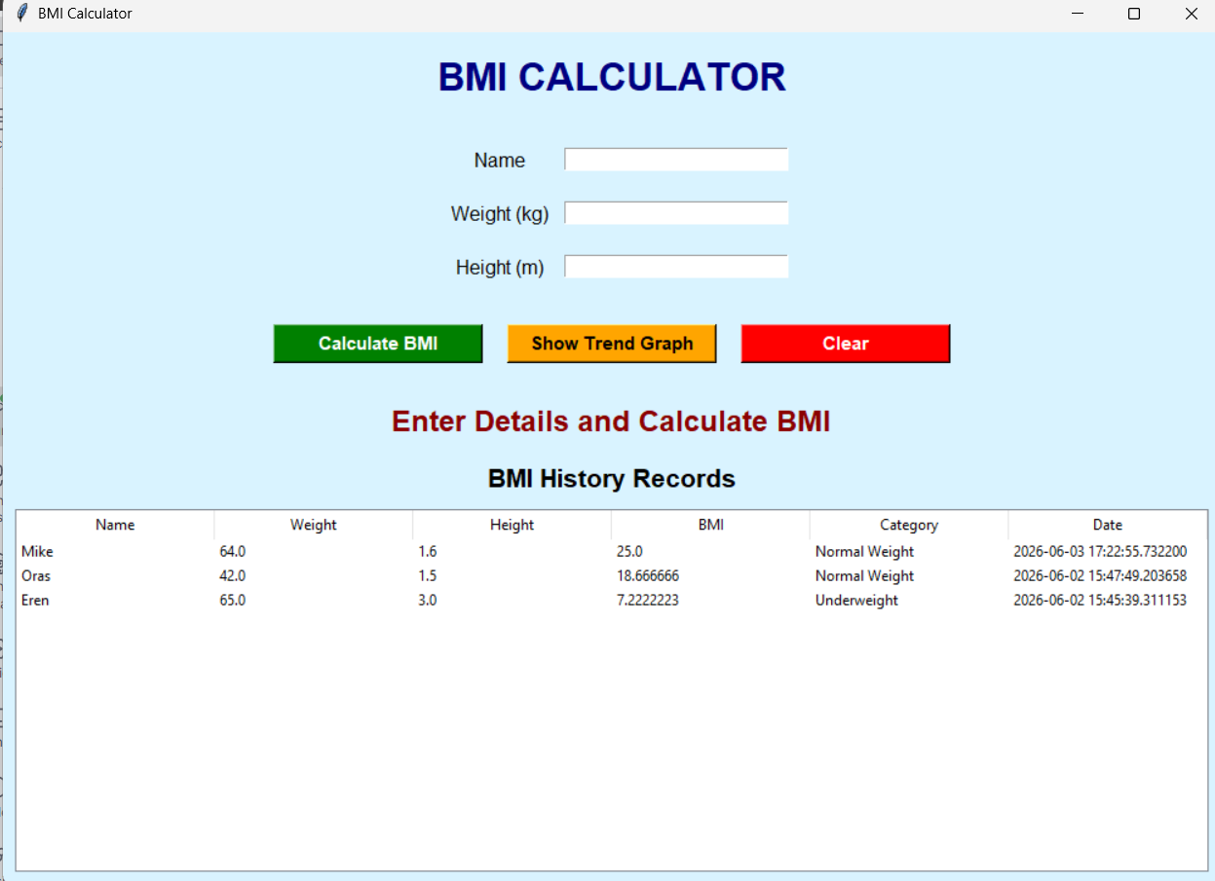
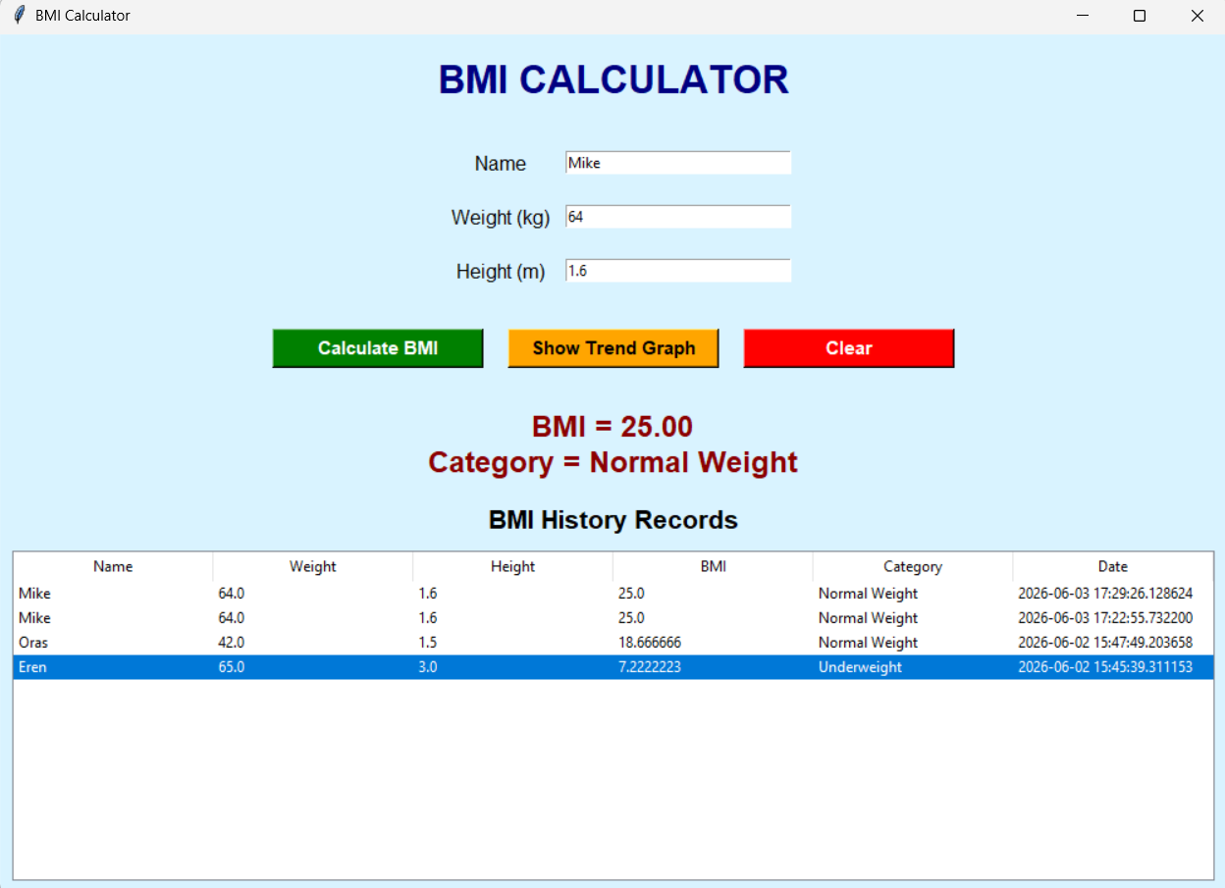
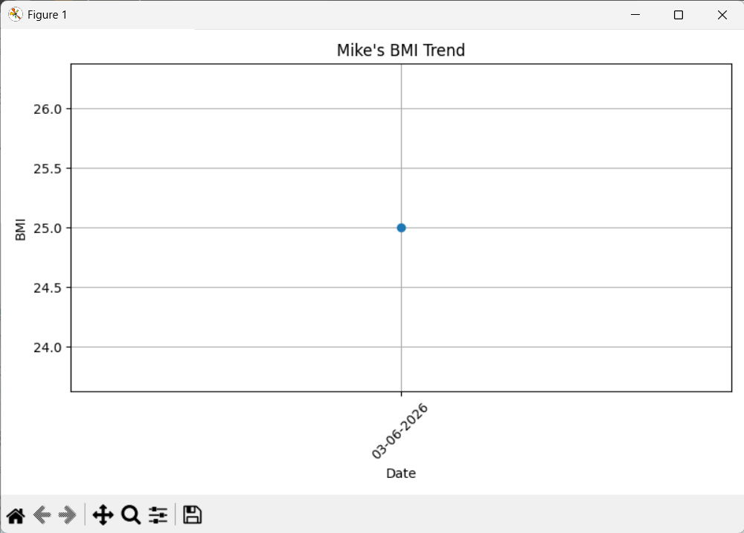

Conclusion-
This BMI Calculator takes Name, Height and Weight form user and then it analysis it using the BMI Formula to get a number and it is then compared based on that a condition is met to satisfy and the result is displayed. As then the data is stored in the table bmi_records to display history

